Software Requirements Specification

for

InSemi

Prepared by Arnav Sampigethaya, Shivam Panda, Siddhant Denzil, Lohit Kamatham

InSemi Technology

19.05.2020

Table of Contents

Contents

1. Introduction 1

1.1 Purpose 1

1.2 Project Scope 1

2. Overall Description 2

2.1 Product Features 2

2.2 User Classes and Characteristics 2

2.3 Operating Environment 2

3. System Features 3

3.1 Login Service 3

3.1.1 Description and Priority 3

3.1.2 Stimulus/Response Sequences 3

3.1.3 Functional Requirements 3

3.2 Time Tracking 3

3.2.1 Description and Priority 3

3.2.2 Stimulus/Response Sequence 3

3.2.3 Functional Requirements 3

3.3 TimeSheet – Middle Tier 3

3.3.1 Description and Priority 4

3.3.2 Stimulus/Response Sequences 4

3.3.3 Functional Requirements 4

3.4 TimeSheet – Human Resources Level 4

3.5 TimeSheet – Admin Level 4

3.5.1 Description and Priority 4

3.5.2 Stimulus/Response Sequences 4

3.5.3 Functional Requirements 5

# Introduction

## Purpose

The purpose of this program is to create a tool for clients to manage administration functions and for users to track and manage productivity in the workplace.

## Project Scope

The scope of this project will expansive, it can be used in any corporation or multi-tiered administration system. It will be scalable to fit the needs of the client by using modularity and APIs. Features include –

* Attendance tracking
* Leave System
* User Reports
* Hierarchy Management
* Data Analytics
* Deadline and Project Management

## Legend

* HLU – Higher Level User
* LLU – Lower Level User

# Overall Description

## Product Features

## User Classes and Characteristics

## Operating Environment

It can operate across all platforms using Kivy library of Python.

# System Features

## Login Service

### Description and Priority

Login using predetermined usernames (company e-mail) and password (can be changed by each user).

### Stimulus/Response Sequences

User will need to enter email and password to login.

### Functional Requirements

REQ-1: Emails must be matched with Database

REQ-2: Passwords must be hidden while typing

REQ-3: User-account type must be determined

## Time Tracking

### Description and Priority

Users can log time spent on activities using a simple START/STOP system. Activities will be pre-determined by HLUs.

### Stimulus/Response Sequence

Users will be able to choose activity from a drop-down list.

Users will be able to use a START/STOP button.

Once any activity is started, attendance it automatically logged for the user, to be viewed by HLUs.

### Functional Requirements

REQ-1: Calendar

REQ-2: Drop-Down List with Synced Features

REQ-3: Start/Stop Button with Stopwatch

REQ-4: Text Area for Additional Comments

REQ-5: Option to Save as Draft

REQ-6: Option to Submit for Approval

REQ-7: Attendance Reflected by TimeTracker Activities

REQ-8: Status

## TimeSheet Viewer

### Description and Priority

This feature is built for HLUs to track subordinates. They will be able to access the TimeSheet database and view the attendance, the progress and reports of their LLUs. Additionally, they will be able to set deadlines and assignments for their LLUs (which will reflect in the Time Tracking feature)

### Stimulus/Response Sequences

* HLUs will have the option to find LLUs by either search or select.
* Search will be based on – First Name, Last Name, Employee ID, E-Mail Address
* Once selected, HLUs will be able to view attendance, reports and progress of the LLU.
* They will also be able to Approve the TimeTracker Report submitted by the LLU.
* HLU will be enabled to edit the LLU’s Calendar by adding assignments and Deadlines (which will reflect in the Time Tracking feature)

### Functional Requirements

REQ-1: Calendar

REQ-2: Search-Bar

REQ-3: List of LLUs

REQ-4: Attendance Report

REQ-5: Progress Report

REQ-6: TimeTracker Report

REQ-7: Approval System

REQ-8: Calendar-Editing Using Deadlines/Assignments

REQ-9: Assignments/Deadlines must reflect in LLU TimeTracker

## Leave System

### Description

LLUs will be able to apply for leaves which have to be approved by HLUs. LLUs can also declare leaves on the day for emergencies.

### Stimulus/ Response Sequences

* GUI with choice between Apply For Leave or Immediate Leave
* Select Duration and add Comments (through Drop-Down or Other)
* HLUs can choose to accept or deny. The choice will be reflected in the LLU’s TimeSheet

### Functional Requirements

REQ-1: Calendar

REQ-2: Choose Duration

REQ-3: Add Comments from Drop-Down

REQ-4: Classify as Application/Immediate

REQ-5: Save to TimeSheet

## Notice Board

### Description and Priority

A GUI Panel showing essential cards with various types of information pertaining to – TimeSheet, Meetings, Deadlines, Peer Activities

### Stimulus/Response Sequences

* Filter
* Interactive Cards – RSVP, Access TimeSheet, View Peer Activities, View Messages, Viewing Deadlines
* Adding Cards
* Announcements by HLUS

### Functional Requirements

REQ-1: Notice Board GUI

REQ-2: Interactive Cards

REQ-3: Access Calendar for Meeting RSVPs

REQ-4: Access TimeSheet for Pending TimeSheets

REQ-5: Access TimeSheet for Peer Activities

REQ-6: Peer Activity GUI

REQ-7: Access Calendar for Deadlines

REQ-8: Add Meeting Card GUI

REQ-9: Meeting Scheduling

REQ-10: Meeting has to be stored into the Database

REQ-11: Collect HLU cards from Notice Board System and Display

## Data Analytics

### Description and Priority

View Graphical Representations of Attendance, TimeSheet and Activity Reports. Predict LLU/Peer Behaviour during Meeting Scheduling.

### Stimulus/Response Sequences

* AI-enabled Search to view Graphical Data
* Chart Creation on Demand
* Prediction of Attendance and Deadline Completion for Meetings and Assignments

### Functional Requirements

REQ-1: AI-Enabled Search

REQ-2: Receiving Search data and Processing Graphs

REQ-3: Pre-prepared Graph GUI

REQ-4: Prediction Algorithm for Attendance (Time, Date, Assignment)

REQ-5: Prediction Algorithm for Deadline Completion (Previous)

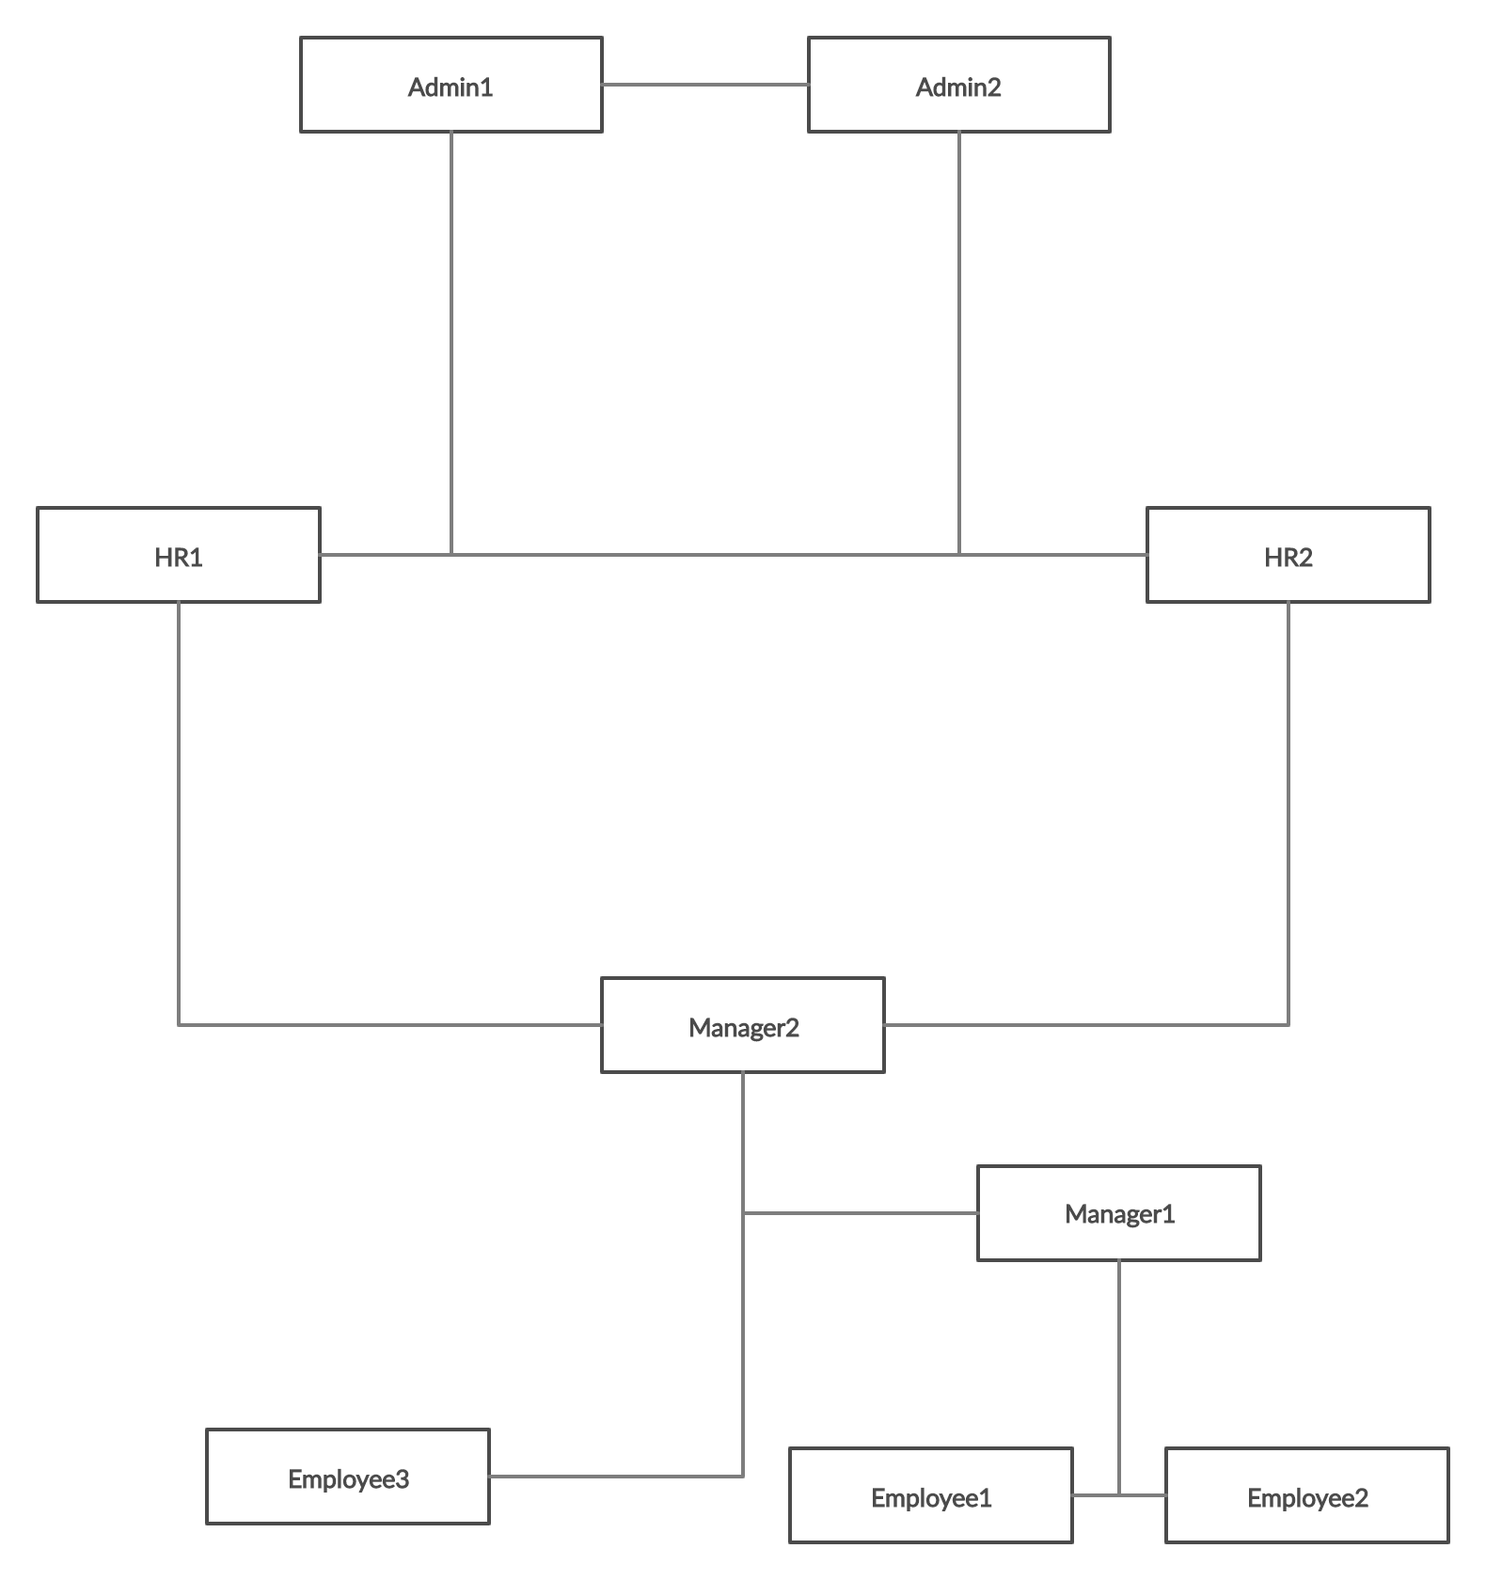

APPENDIX

#### Add User

* Backup the data
* First Name
* Last Name
* Employee ID
* Email
* Password
* Type of User
* Define the Hierarchy (from XLSX)
* Enable unlock of restricted features
* Backup the data

1. Remove User
   1. Backup the data
   2. Update the hierarchy
   3. Delete the user
   4. Backup the data
2. Edit the User
   1. Backup the data
   2. First Name
   3. Last Name
   4. Employee ID
   5. Email
   6. Password
   7. Type of User
   8. Define the Hierarchy (from XLSX)
   9. Enable unlock of restricted features
   10. Backup the data
3. Employee Database(Hierarchy) Management
4. TimeSheet Database Management
   1. Holiday Management (Disabling timesheets for Non-Working days)

Features of TimeSheet –

1. Calendar (Can View Month, Days)
2. Restriction – Only Last Two Months (for User)
3. View Hierarchically – Reportees
4. Search – Employees(First Name, Last Name, Email, Employee ID) –( Date Range )
   1. Restrictions - Hierarchical
5. Edit
6. Save (locally – Employee, Admin)
7. Submit for Approval
8. Export (.xlsx) – (Date Range)



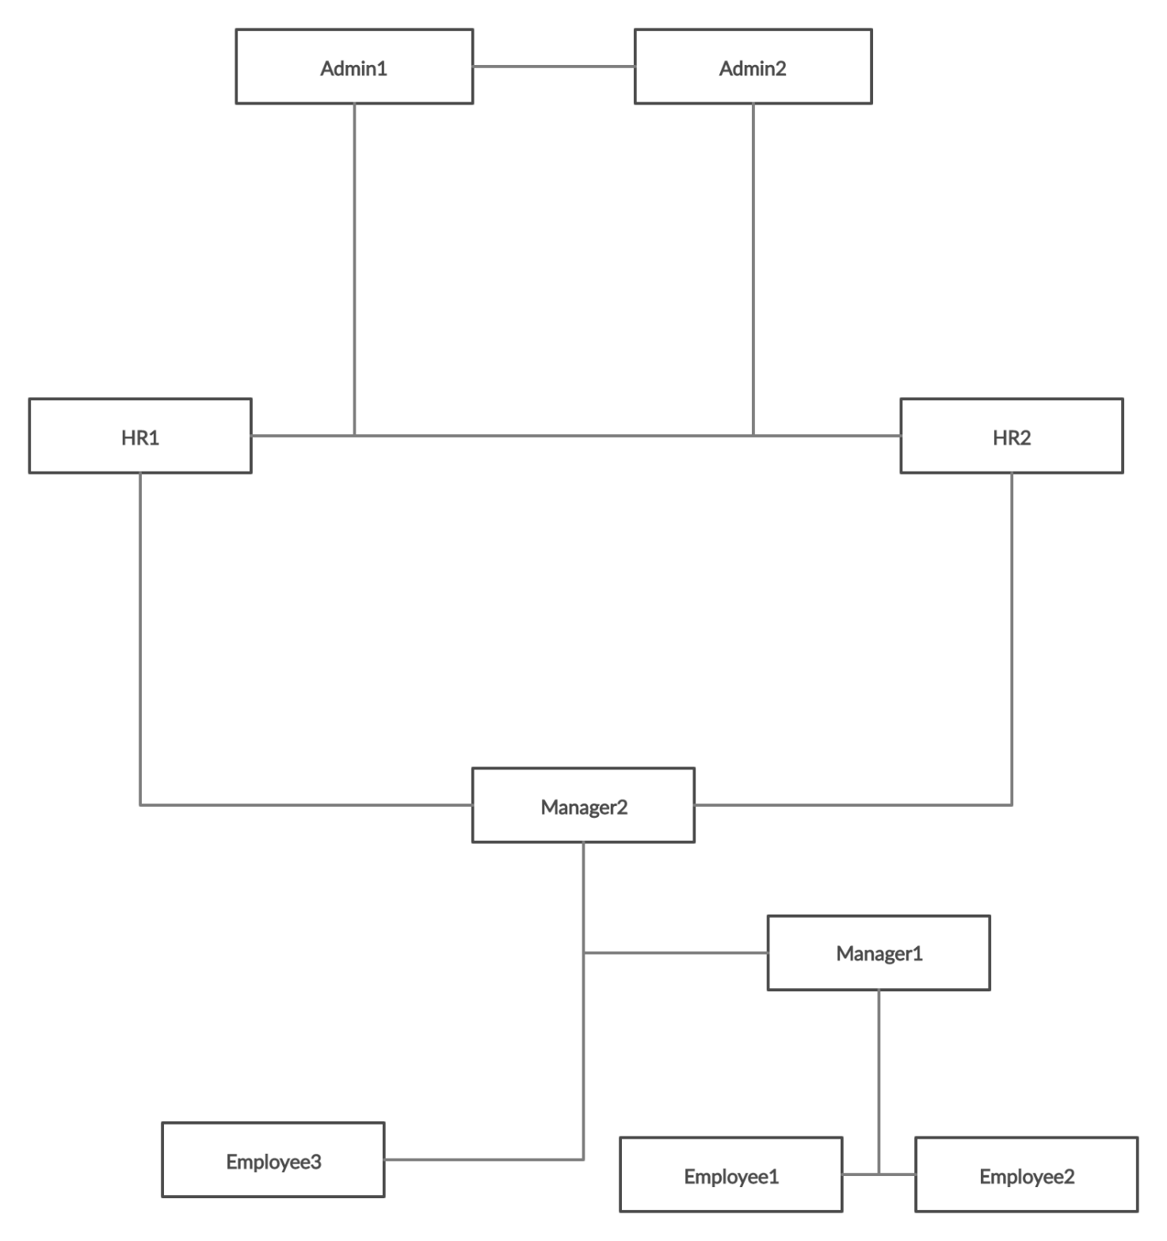

a

